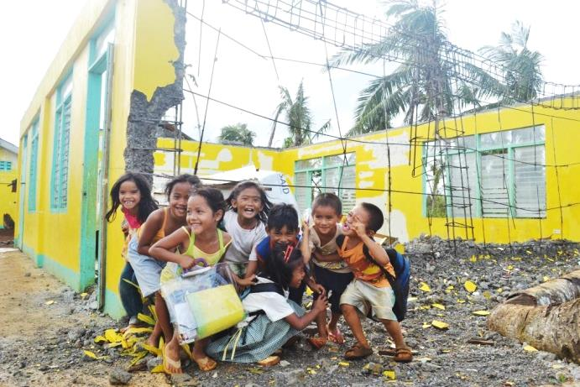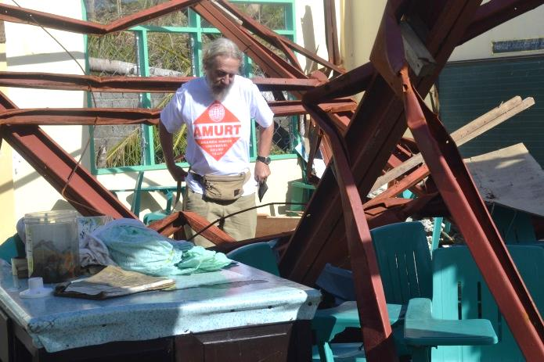
- School Repair and Reconstruction Program after Typhoon Haiyan Eastern Samar, Philippines
When we saw the heavily damaged Central Elementary School in Salcedo/Eastern Samar six days after Typhoon Yolanda we immediately agreed it should be included in our relief program. As other school campuses did not look any better and were in an equally bad condition, we decided to come up with a whole package of school repair and reconstruction plan to bring a large number of children back into a permanent structure. With a budget of 1,300,000 USD we could choose 109 school buildings to improve upon. Selection criterion was to prioritize schools with the biggest student population, no matter how badly they were affected! It goes without saying that the biggest schools also proved to have the most damage.
Our initial intent was to begin repair work right away mitigating the need for tarpaulins and temporary learning spaces. But in the early days it was difficult to source building materials locally. Also transport without trucks and gasoline was a challenge. Civil engineers were hired from far away, but more were needed to meet our goal in a timely fashion. To maximize the funds we avoided outsourcing to contractors and opted to do all the work in house. The scope of work totaled 109 school buildings, which is everything but an easy undertaking. Logistical support increased daily. Our dedicated logistics staff consisting of 18 individuals used three trucks to deliver materials around the clock.
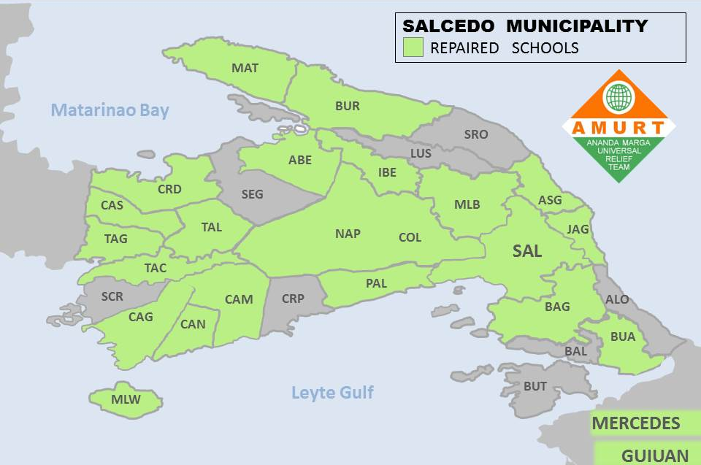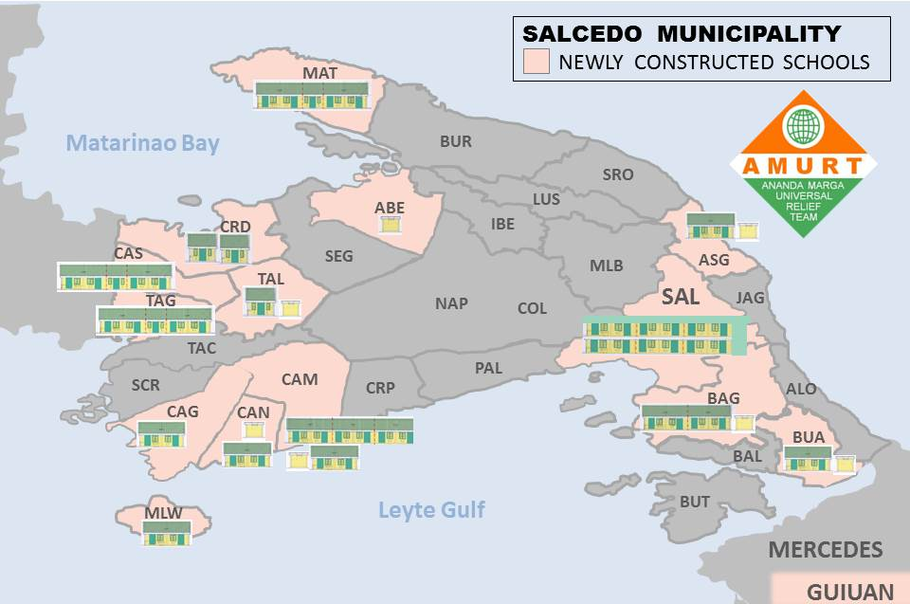

It was outlined in the Memoranda of Understanding that a general renovation is not included in the emergency measures. In many cases, however, the structures were so run down that additional measures were considered necessary. By avoiding out-sourcing we could cut down on expenses and allocate funding towards additional upgrades and improvements. In the end our repair work was equivalent to a full-fledged renovation. It was amusing when visitors could not tell the difference between the old buildings and the new ones!
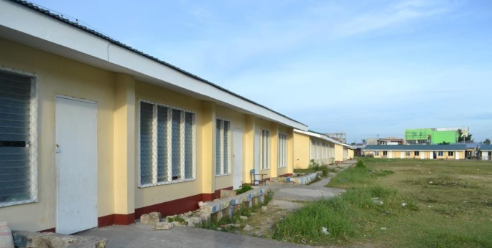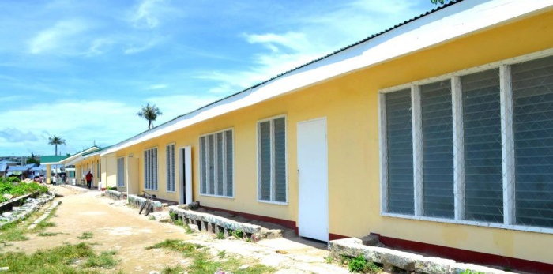
Guiuan East Central ES: more than a kilometer of new façades!
We were working under tremendous time pressure. According to the original plan, repair work was to be completed by the beginning of the new scholastic year. What a relief when the pupils could once again use their classrooms rather than occupy the hot and stuffy tents!
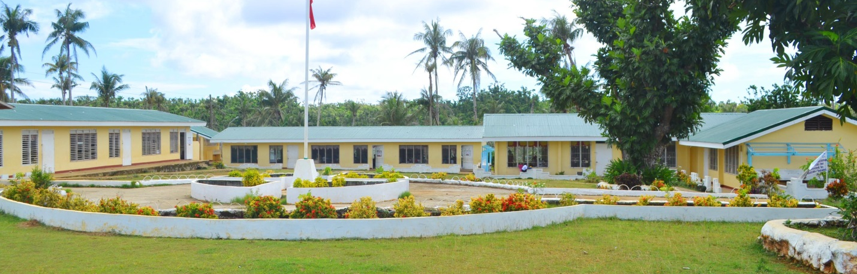
Mercedes Central ES: our first accomplished school campus
The construction of 16 new permanent buildings with a total of 39 classrooms started back in March 2014. Over-all we followed the principle: “Build back better”. Small sub-standard structures were replaced by bigger, stronger ones. AMURT/AMURTEL exceeded expectations by providing “extras” like principal’s offices, canteens, home economics classrooms, toilet structures, storage facilities and perimeter walls. All construction work was finished by September 2014.

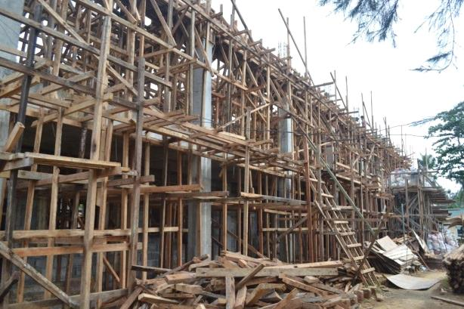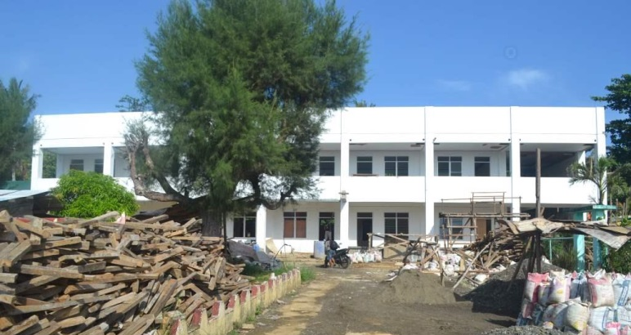
Salcedo Central ES: a new two-story building replaces two totally destroyed structures

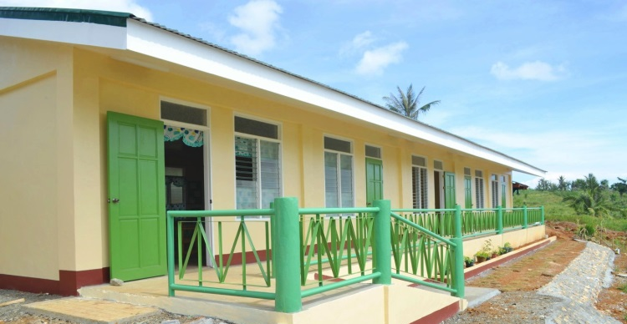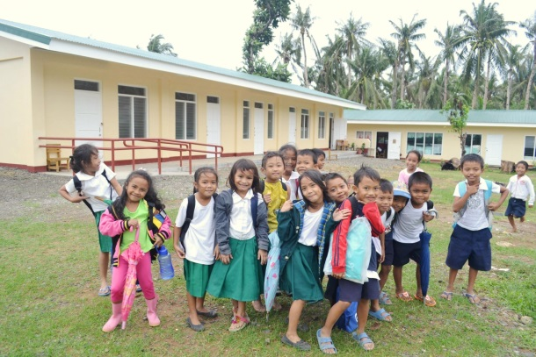
Casili-on ES new building: enlargement of the school campus Matarinao ES: We care for the children of Eastern Samar!

It was rewarding to see campuses shine like new, filled with happy children and happy teachers. AMURT/AMURTEL hope that with their contribution to the education sector they could make a small difference! Our success was made possible by the active support from KINDERNOTHILFE Germany who made available the necessary funds. The Secretary General of Education visited twice the AMURT/AMURTEL projects. Even the President of the Philippines, Benigno Simeon C. Aquino III came and declared our schools a showcase for successful relief work!
