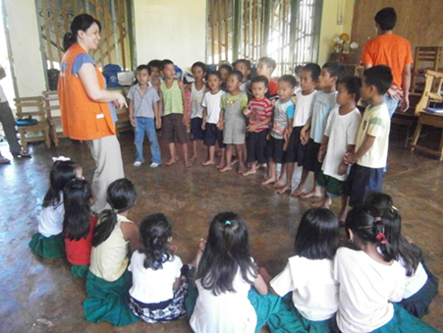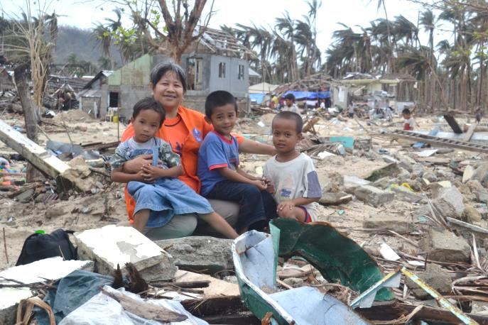
- PSYCHOSOCIAL – TRAUMA HEALING Eastern Samar, Philippines
When Children have no home, no TV, no toys, no playgroups, and nobody who has time to take care of them, they are extremely vulnerable. Their lives are uprooted. They lack the habituated protected environment. Many families not only lost all their possessions but had casualties amongst their family members. Children sense the anxieties of their parents who are taken up with coping strategies. This is the time when children need special care, a lot of love, fun and above all a child-friendly environment.
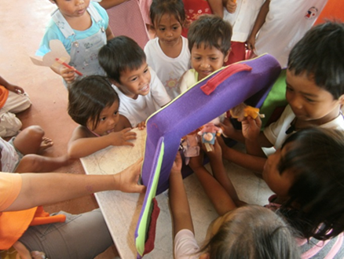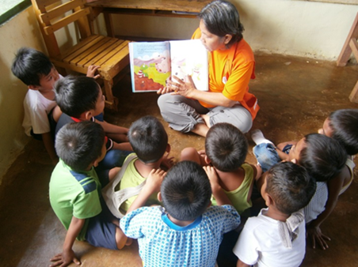
AMURTEL hired an Early Childhood psychologist and a group of social workers to start playgroups in 11 Barangays of Salcedo municipality as the employed municipal day care workers were not available. Their working power was needed in the municipality to prepare and organize the ongoing relief distributions. Didi Ananda Shubhra trained her team in trauma treatment and guided them in their psychological approach to let children express the traumatic experiences they had gone through.
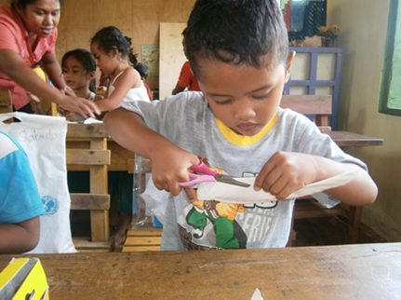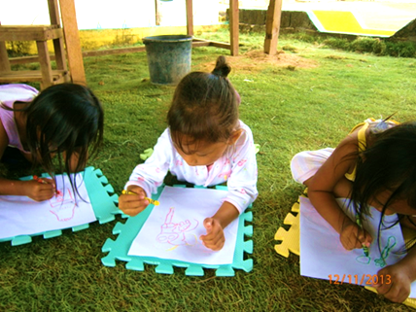
Art work, drama, dance and play are effective ways to help children overcome their anxieties. Whenever rain clouds moved in, children started to cry out of fear another typhoon might come and destroy what was left from the previous one. According to our psychologist, adults were generally more traumatized than the children. That’s why we extended our program and included the mothers in our counseling sessions. After 6 months we could phase out. The day care workers were back in their duties and their broken centers had been repaired.
