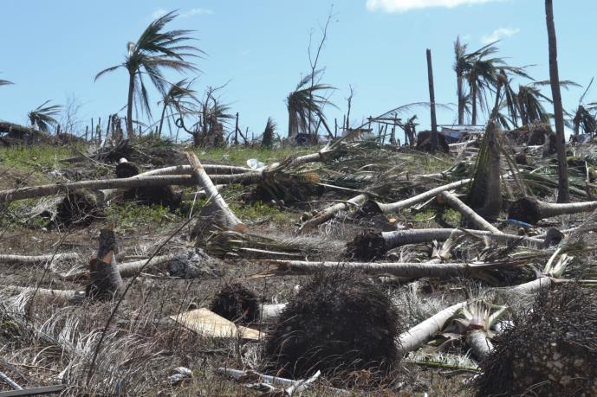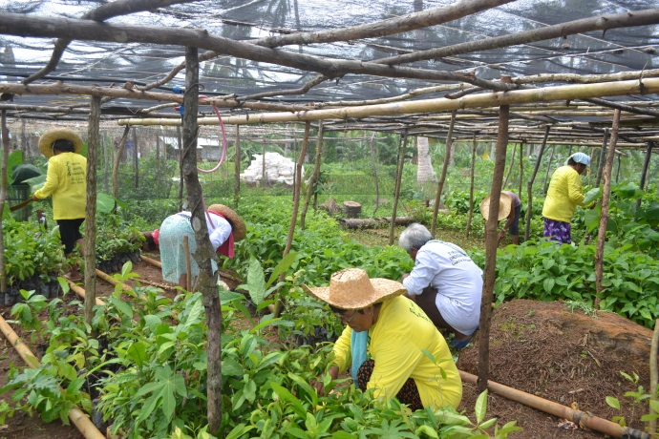
- Livelihoods / Organic Agriculture after Typhoon Haiyan/Yolanda Eastern Samar, Philippines
The population that was affected by Super Typhoon Haiyan/Yolanda lost all their assets needed for income generation. In January 2014, AMURT/AMURTEL started a program to assist farmers in rebuilding their lives. We adopted the two Barangays of Jagnaya and Asgad for an over-all rural development. More than 70% of the coconut trees were uprooted by the strong winds and fell. Knowing that coconut industry is the primary source of income of the region, one can understand the extent of the disaster. Farmers cannot sit and wait for a new generation of palm trees. It takes them 7 to 8 years to grow until they yield crops again. To make the rural population more resilient for future catastrophes, we introduced intercropping with organic, environmentally friendly plantation techniques.
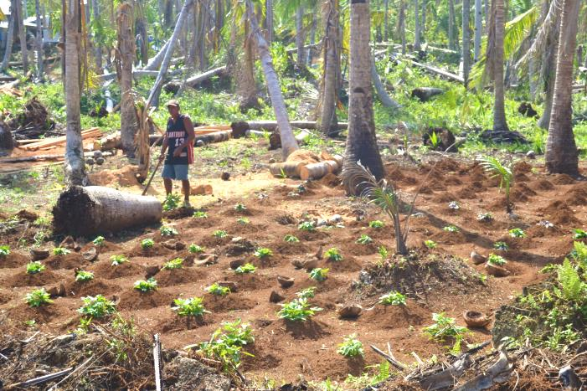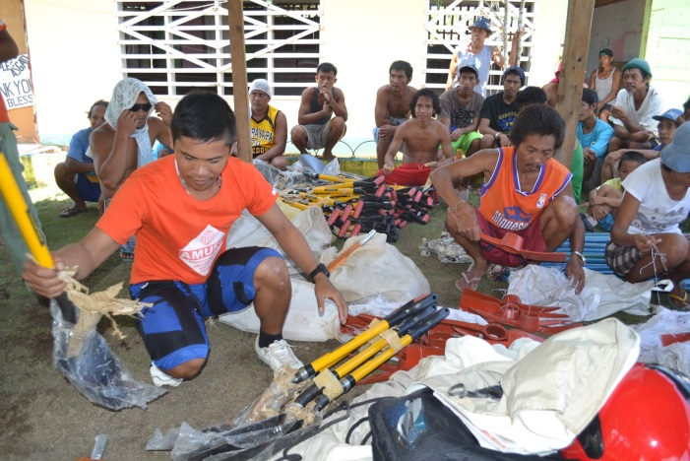
In the first phase, we provided chainsaws, grass cutters and hand tools for land clearing. The newly set up farmers’ association and cooperative received tools, seeds and seedlings for their members, machines, water pumps and generators to get started.
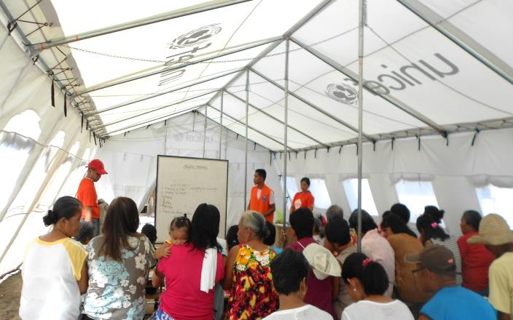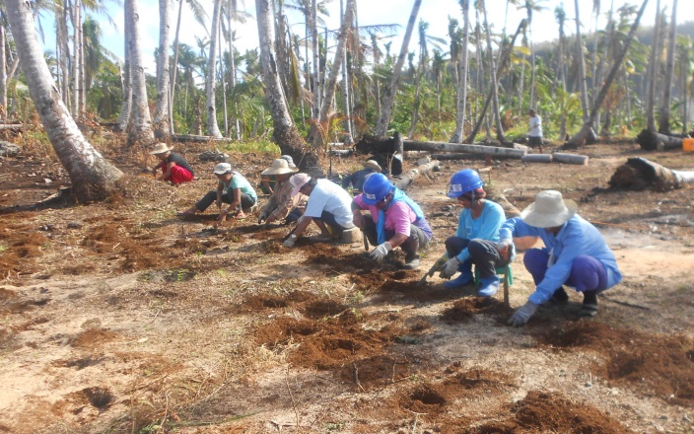
As root crops and vegetables are new to the farmers we had to conduct training courses in farm planning, planting techniques, composting, soil management, pest control, etc. The classroom seminars were accompanied by hands-on training in the community garden where they earn and learn collectively. Having access to resources and implements farmers really got inspired and developed a lot of self-initiative.
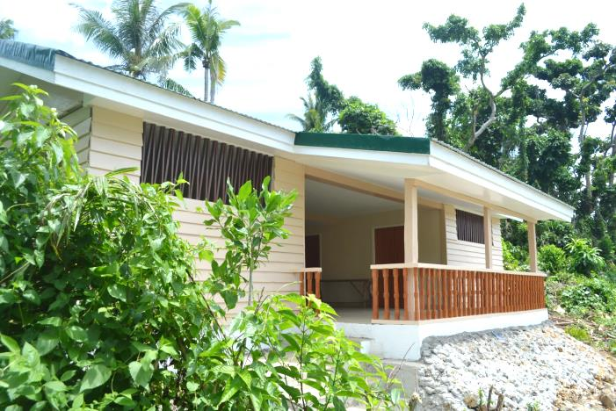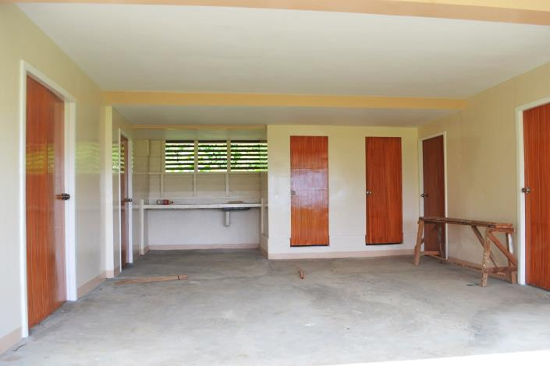
Jagnaya Agro Center as a venue for meetings with kitchen and sanitation, with storage facilities, a laboratory and an office.
After covering the needs of Asgad and Jagnaya, we reached out to other remote Barangays for similar assistance. The village Iberan with its active and vibrant Farmers’ Entrepreneurs’ Association deserved support to build up their capacities. AMURT/AMURTEL invested in nursery structures for the 10,000 jungle trees as part of the afforestation program and for the purchased 50,000 coffee trees which will make Salcedo the coffee center of Eastern Visayas. We shipped in truckloads of fertilizer and provided needed machines and implements.
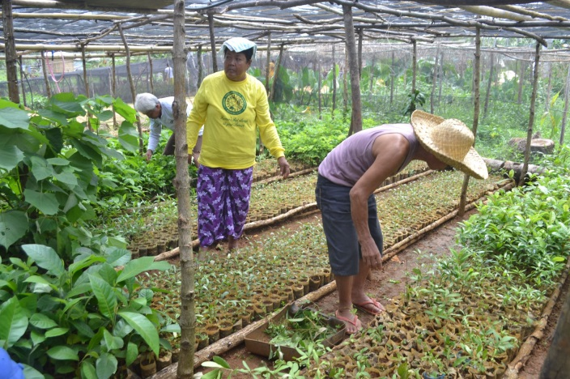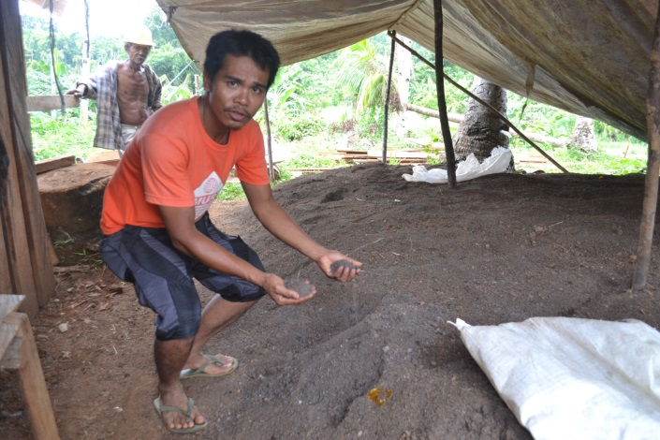
20 senior citizens have been employed to take care of the plantations. The result of a composting workshop: 6 tons of high-quality humus soil.
We still had left-over money from our 200,000 USD budget and were looking for meritorious recipients to make maximum utilization of it. The mayor of Selcedo invited us to an ocular inspection of the totally demolished municipal Demonstration Farm which was a traumatic experience. All activities had come to a halt. In his vision, the mayor aimed for a Model Farm that could produce enough seeds and seedlings, fertilizer and pesticides for all farmers in the municipality. It would also contribute towards self-sufficiency and food security for its sake of all residents in future disasters.
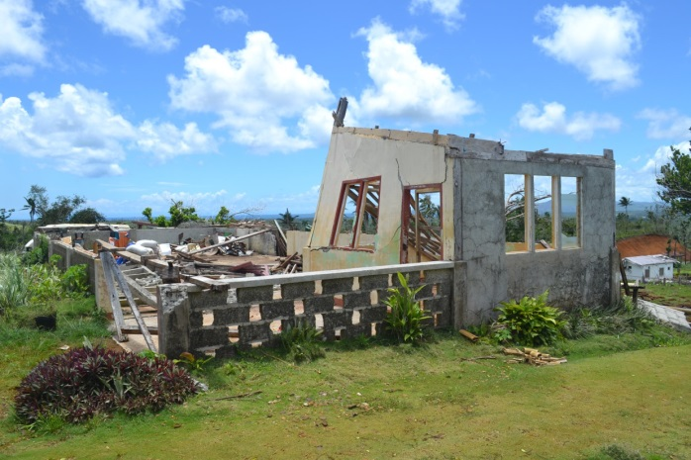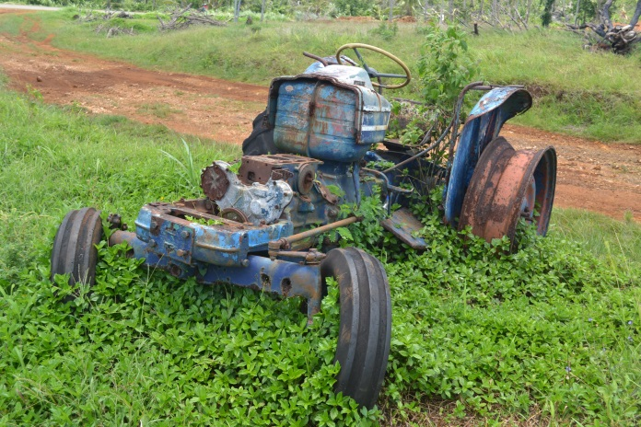
A project where 2,000 local farmers could be benefitted made sense. With the help of two Agro-Engineers we immediately started planning. And this is the outcome:
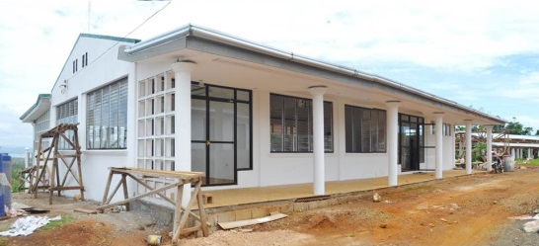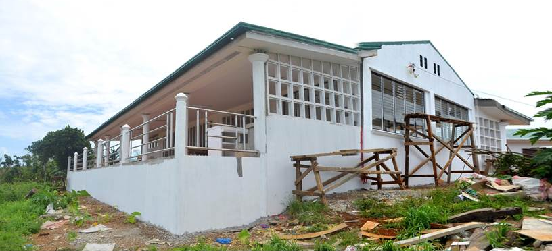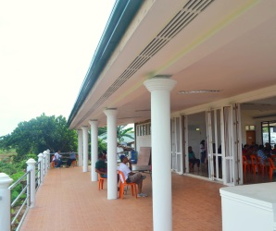
A new training center for all farmers in the municipality with a seating capacity of 200, canteen, and a spacy sanitation section.
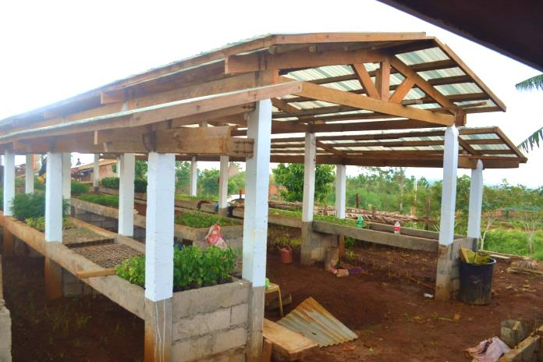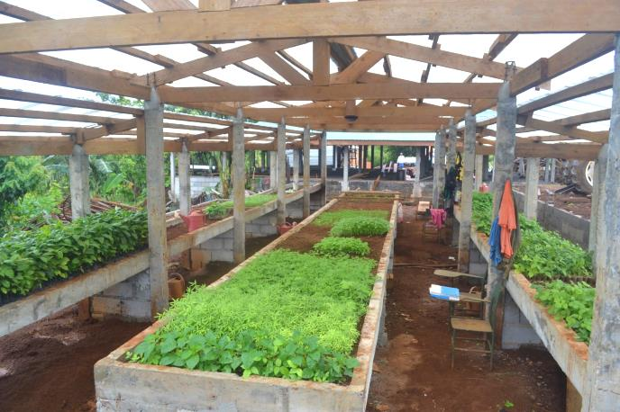
Nursery buildings for production of seeds and seedlings;
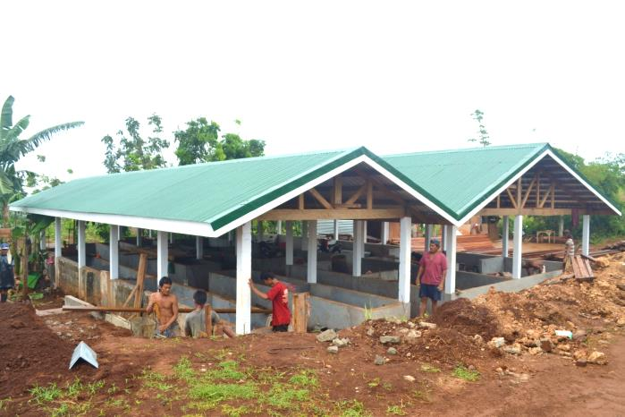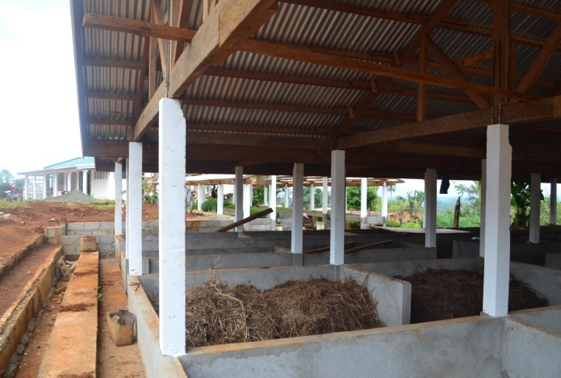
A composting area with 10 beds for vermin-culture and 15 boxes for compost making;
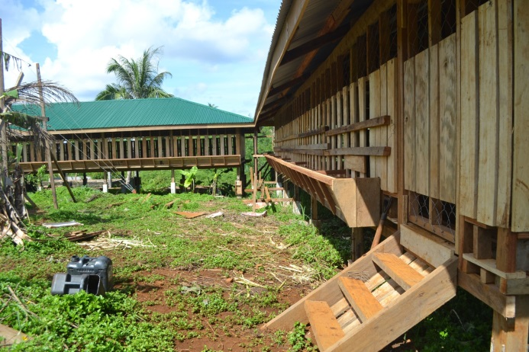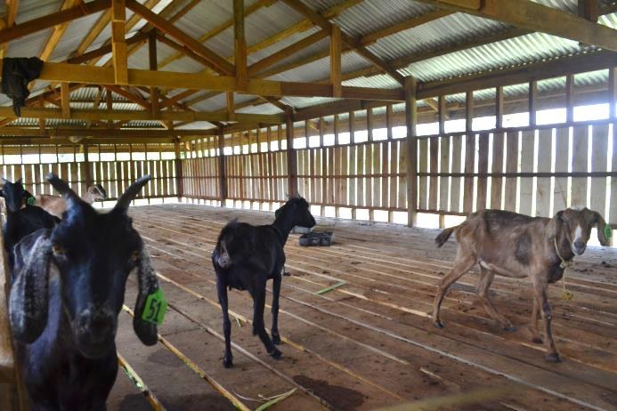
Goats’ houses for a capacity of 150 heads.
The Provincial Department of Agriculture has declared the new Demo Farm in Salcedo the biggest and most successful Demo Farm in Region VIII (comprising Samar and Leyte). Salcedo was declared multiplier center of small ruminants for the whole province. The Department allotted 11M Pesos for support programs as all the requirements have been fulfilled.

