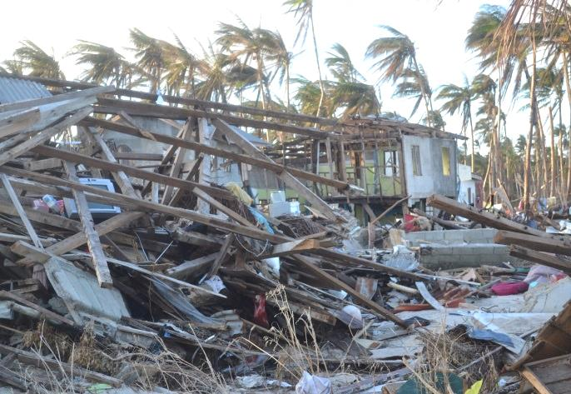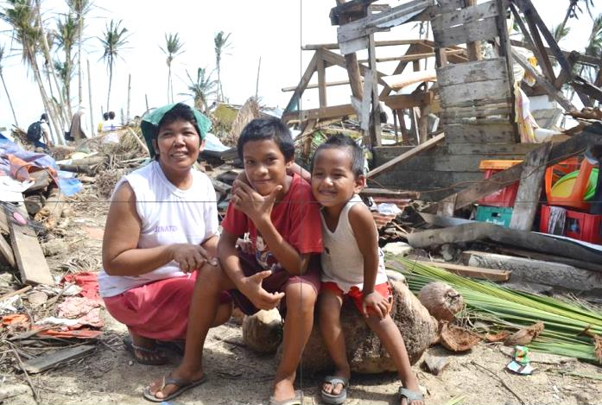
2) Shelter Repair and Permanent Housing after Typhoon Haiyan Eastern Samar, Philippines
The municipal mayor of Salcedo/Eastern Samar sent us to two coastal Barangays, Jagnaya and Asgad on the Pacific Ocean which were the worst affected during Typhoon Haiyan/Yolanda. Within seven days AMURT/AMURTEL started to repair the structural damages of those few houses that were still standing. In most cases, the roof had flown away, the window glass panes were broken and the attached kitchens had collapsed. It took some time to find the necessary building materials. The stocks of all local hardware suppliers had been destroyed by the typhoon.
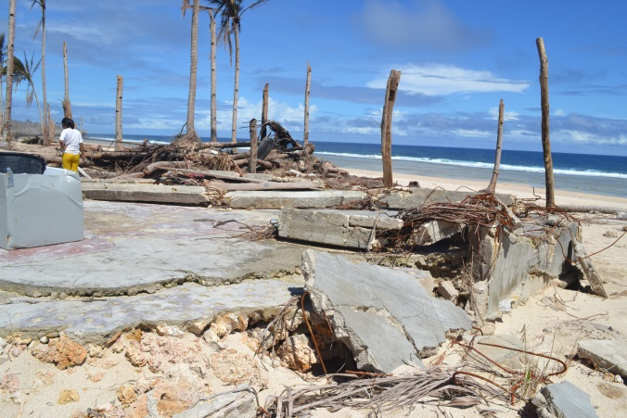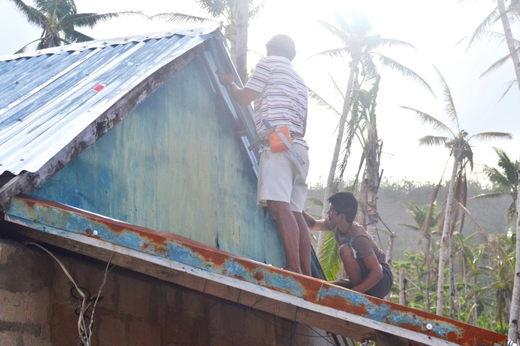
Barangay Jagnaya: even strong structures were crushed by the storm surge. Local craftsmen mounting roofing sheets
96% of the houses were totally “washed out” as they were located in the endangered No-Build-Zone along the beach front. People were busy collecting recyclable materials to re-assemble them into temporary shelters that could protect their families from heavy rains. One week later, the planning was done. In consultation with the affected households, who all submitted plans and sketches of their “dream house”, AMURT/AMURTEL developed two different house designs of 36 m² with an iron-concrete frame that are strong enough to resist typhoons and earthquakes. The roof is embedded between two firewalls so that it cannot fly away. We gave the future house owners choices where to put the doors and windows and how to partition the rooms.
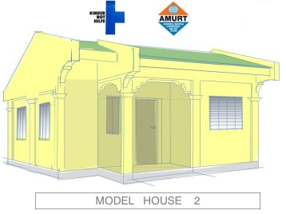
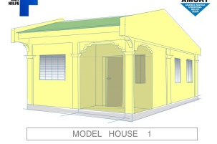
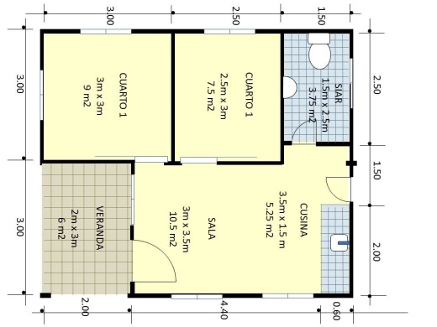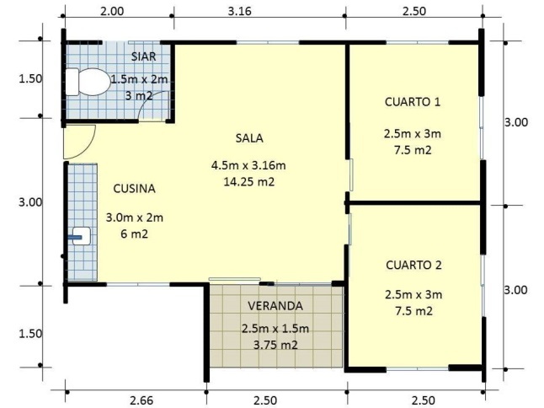
The municipal mayor gave us two plots of 2 hectare so that a total of 117 households could be relocated to the Safe Zone. All beneficiaries were delighted when they heard they would get a land title for their 140 m² parcels. Clearing the coconut tree jungle was a major challenge as the terrain proved to be extremely rocky, almost inaccessible. As in our school project, AMURT/AMURTEL avoided outsourcing to contractors, instead hired workers and laborers from the villages to build their own houses. This approach is much more labor intensive but provides employment for more than 400 residents and strengthens the local economy.
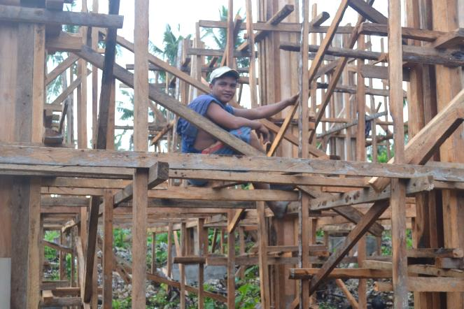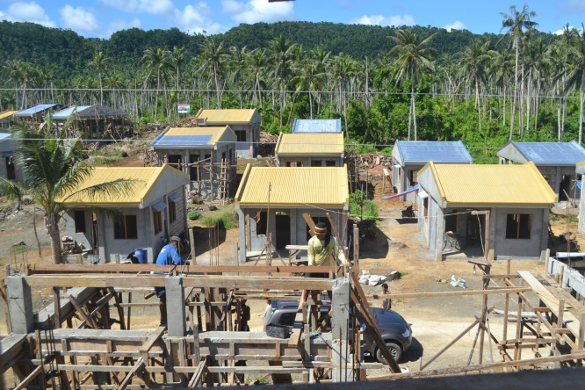
Enthusiastic construction work in Asgad. Houses are mushrooming in Asgad. The speed is incredible!
Our first cement order was 20 sacks. That’s what we could get. Meanwhile we need 7,000 sacks a week.
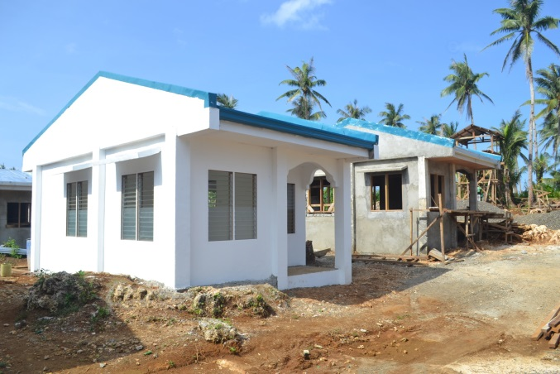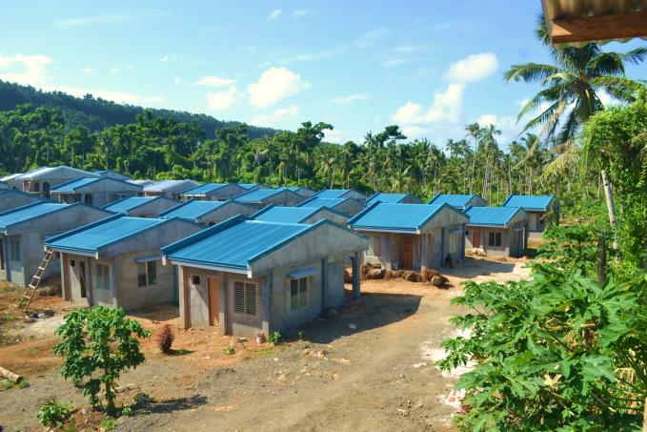
In the shelter cluster AMURT/AMURTEL was acknowledged for its pioneer role in putting up permanent houses and going through the long and troublesome process of relocation. The “First International Commission on Disaster Risk Reduction” highlighted three of our five projects as exemplary. Over the months, the construction sites developed into tourist attractions. Every day different shelter organizations come to see our unique housing scheme in progress. The project is not cheap. Our partner KINDERNOTHILFE from Germany agreed to a budget of 1,300,000 USD. It is an investment to mitigate typhoon damages in future.
