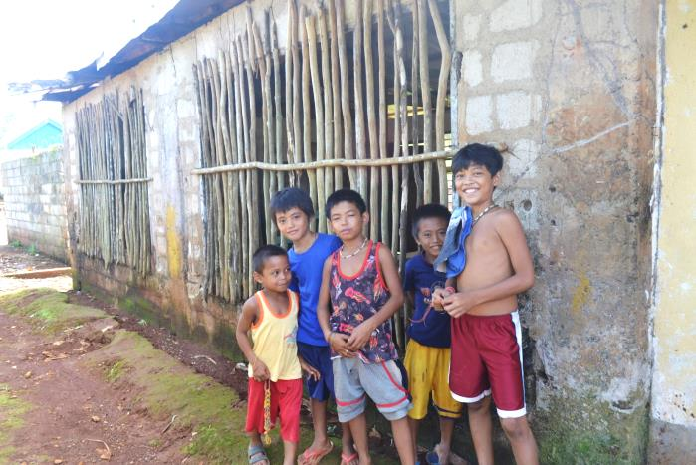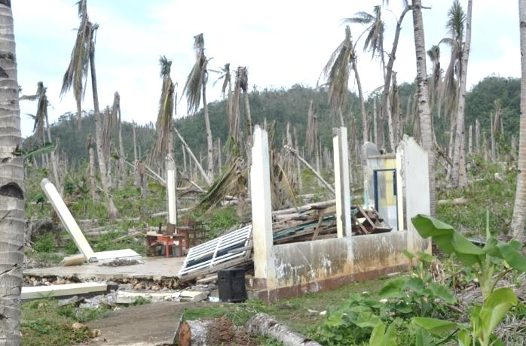
- Rehabilitation and Reconstruction of Day Care Centers after Typhoon Haiyan/Yolanda Eastern Samar, Philippines
In the aftermath of Typhoon Haiyan/Yolanda, pre-school-aged children had no place to go. None of the 34 day care centers was functional. Buildings were devastated. Toys and teaching materials were lost. AMURT/AMURTEL along with its partner KINDERNOTHILFE tailored a program to rehabilitate 18 facilities that had suffered heavy damages, to reconstruct 5 centers that had literally disappeared, and to equip all of them with furniture, materials and playgrounds. We were entrusted 200,000 USD to achieve all these goals.
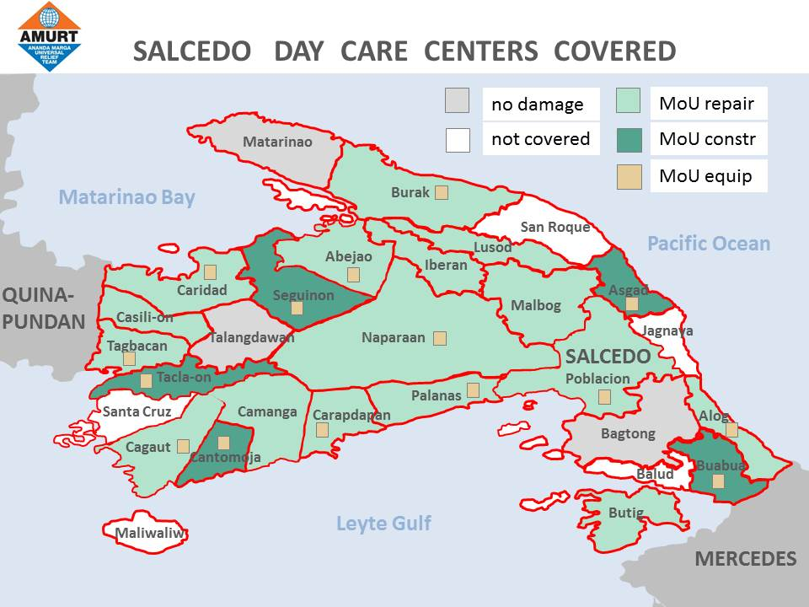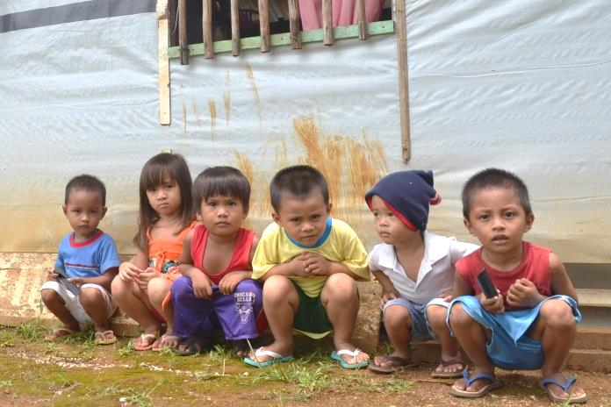
Our intention was to bring all the Kindergartens on our list up to standard. To patch roofs, walls, or replace windows was only part of our job. Samar Island is one of the poorest areas in the Philippines. The word “standard” and its connotation were unheard of. The situation we found – dark, gloomy rooms with some broken chairs and a prehistoric blackboard – was everything but inspiring. We wanted to turn these places into modern Early Childhood Care and Development Centers.
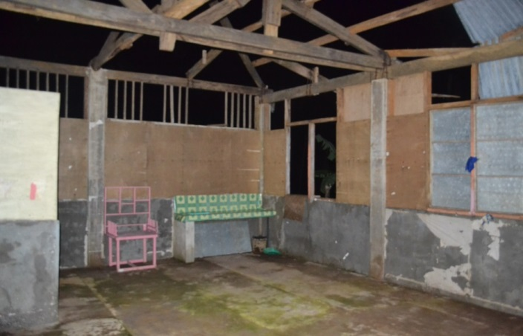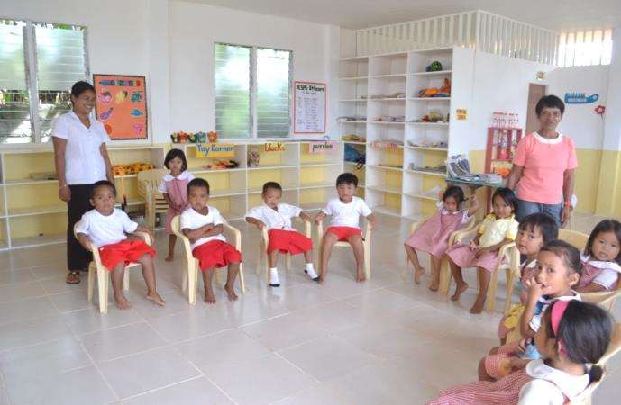
Palanas Day Care Center before ….. ….. and after our intervention.
Apart from the cosmetic face lift, AMURT/AMURTEL provided hygienic toilets with hand washing sinks and kitchen addenda for catering. For the first time, centers have piped water and electricity. The new shelves are full of interesting books and toys. It is amazing what difference a little amount of money can make when spent wisely!
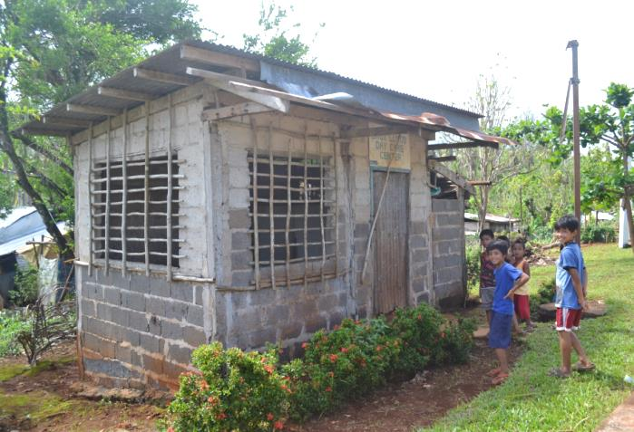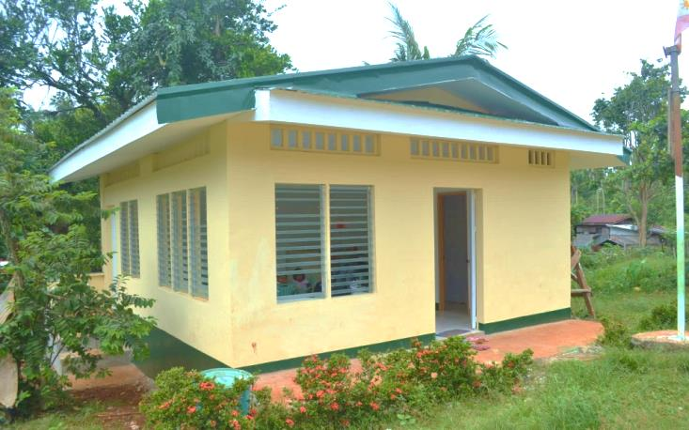
Lusod Day Care Center before …. …. and after the face lift
When we were free to come up with new designs for the totally damaged structures, we experimented with shapes, colors, spaces. Let there be some joy, aesthetics, and excitement in the children’s world! When the residents of Salcedo saw the results they admitted: “We have not had buildings like that before!”
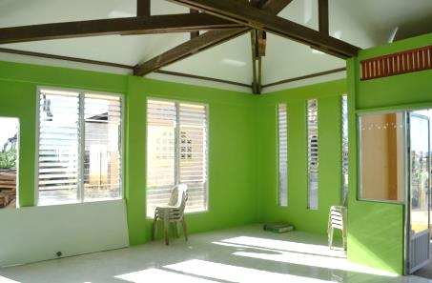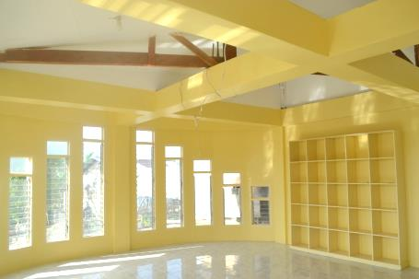
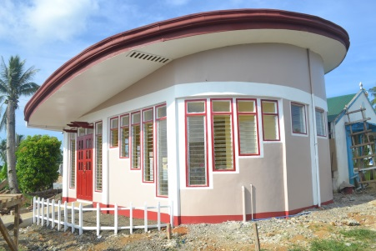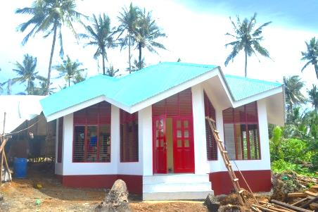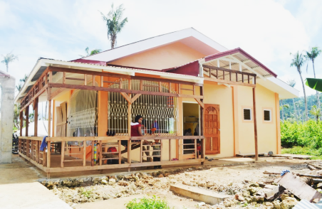
New DCC Tacla-on New DCC Asgad New DCC Buabua
We are not only focusing on the hardware. Didi Ananda Shubhra attended morning classes in many centers and introduced Neohumanist education to teachers and children. She conducted workshops and helped select pedagogical materials. For our 850 children.
